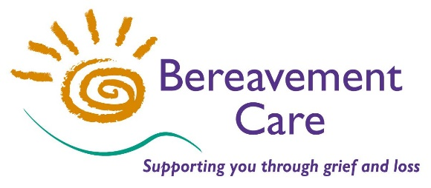
Bereavement Care
The Lodge, 64 Pinner Road
Harrow, Middlesex HA1 4HZ
Telephone: 020 8427 5720
Email: admin@bereavementcareandsupport.co.uk
www.bereavementcareandsupport.co.uk

INITIAL BEREAVEMENT TRAINING COURSE – 16th & 23rd May 2024

A course which covers basic listening and responding skills. It also explores the pattern of grieving, grief and ritual and other aspects to help those who may wish to offer support to
people who have experienced bereavement in their community or place of work.

This course is held over two consecutive weeks

DATE: Thursday 16th May AND Thursday 23rd May 2024

TIME: 10.00am - 3.30pm VENUE: The Lodge, Pinner Road, HA1 4HZ

COST OF COURSE: £90.00 for non – Members
£50.00 for Members

Please make payment by Bank Transfer to: Bereavement Care
Sort Code: 23-05-80 Account Number: 43231545 Reference: IBT
or by cheque payable to: Bereavement Care

Please return applications as soon as possible to secure your place
(no later than 8th May 2024)

PLEASE NOTE: It is our policy not to accept on these courses, anyone who has had a close bereavement within the last two years.
------------------------------------------------------------------------------------------------------------------------------------INITIAL BEREAVEMENT TRAINING COURSE – Thursdays 16th & 23rd May 2024

NAME: …….…………………………………………………………………………………………………………….....

ADDRESS: ….………………………………………………………………………………………………….................

..........………………….................................................................................. POSTCODE: ………………………

PHONE NO(s): …………………………………………………………………………………………………………….

EMAIL ADDRESS: ………………………………………………………………………………………………………..

ORGANISATION: ……………………………………………………….…………………………………………….......

If your Organisation is a Corporate Member of Bereavement Care, you do NOT need to complete the Address, Telephone Number & Group Leader/Sponsor details below.

GROUP LEADER/SPONSOR: ……………………………….……………… SIGNED: …………………………….

ADDRESS: ………………………………………………………………………………………………………..……….

…………………………………………………………………………………. PHONE NO: ……….……....………….

Please detach and return completed form to the Course Administrator at the above address
Please invoice my school/organisation I have made payment of £_____ by BACS

I enclose £_____ cheque/cash

