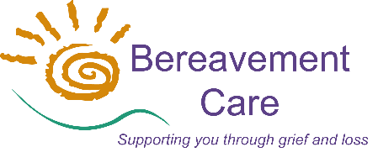
Bereavement Care
The Lodge, 64 Pinner Road
Harrow, Middlesex HA1 4HZ
Telephone: 020 8427 5720
Email: admin@bereavementcareandsupport.co.uk
www.bereavementcareandsupport.co.uk

APPLICATION FOR CORPORATE MEMBERSHIP 2024

NAME OF MEMBER ORGANISATION:

NAME & CONTACT DETAILS OF CORRESPONDENT FOR MEMBER ORGANISATION:

NAME:
ADDRESS:

POSTCODE: TELEPHONE:
E-MAIL ADDRESS:

NAME & CONTACT DETAILS OF NOMINATED REPRESENTATIVE: (if different from above)

NAME:
ADDRESS:

POSTCODE: TELEPHONE:
E-MAIL ADDRESS:

I declare on behalf of (organisation’s name) that we are concerned to further the objects of Bereavement Care and that we agree to follow Bereavement Care’s Codes of Best Practice.

SIGNED: DATE: POSITION:

CORPORATE MEMBERSHIP FEE FOR 1st January – 31st December 2024
The Corporate Membership Fee of £200 p.a.* (January – December) entitles a member to:
- One FREE place on the Initial Bereavement Training Course;
- Reduced fees for additional training, workshops and the Annual Conference;
- The right to vote at any Annual General Meeting (and any Extra-ordinary Meetings);
- An electronic copy** of the Annual Report & Accounts;
- Correspondence sent by e-mail** including newsletters, events and information related to Bereavement Care and its operation.
[* Smaller organisations may be offered a reduced fee at the discretion of the Trustees]
[** Paper copies of documents may be requested by contacting our office]

Please make payment by Bank Transfer to: Bereavement Care
Sort Code: 23-05-80 Account Number: 43231545 Reference: Corporate Membership
YOUR BANK MAY ASK YOU TO DOUBLE-CHECK THESE DETAILS TO ENSURE YOU ARE NOT BEING SCAMMED, AS THESE METRO BANK DETAILS CAN SOMETIMES BE QUERIED IN VERIFICATION
or by cheque payable to: Bereavement Care

Please if your organisation has a Bereavement Visiting Group.

