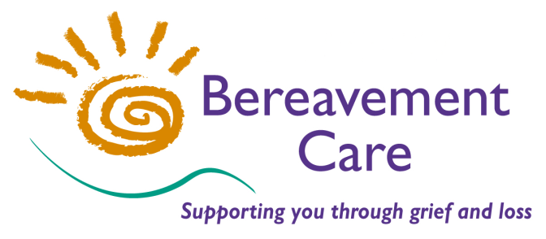

NEWS from THE LODGE

Bereavement Care
The Lodge, 64 Pinner Road, Harrow, Middlesex HA1 4HZ
Telephone: 020 8427 5720
Email: admin@bereavementcareandsupport.co.uk

www.bereavementcareandsupport.co.uk

June 2019 Issue 22

Annual General Meeting  The Bereavement Care AGM took place on 15th May at Emmanuel Church Northwood. We are most grateful to Emmanuel Church for giving us a warm welcome and for hosting our AGM again. Our guest speaker, Joanna Marovitch from The Peace Hospice in Watford, spoke movingly about her work and her experience of end of life care when she was a child and in her current role. Members re-elected Trustees and approved the Annual Report and Accounts for 2018. Sue and Peter Ellis, who both stood down as Trustees at the meeting, were thanked very sincerely for their contributions. |  | 38th Annual Conference NEW VENUE  The 38th Annual Conference for Bereavement Care will be held on Wednesday 30th October this year. St Helen's School in Northwood will provide the NEW VENUE! One of the most important skills that our bereavement visitors need is to listen effectively: and this year our Conference is called HEAR HEAR! and will be focusing on the importance of listening. Our keynote speaker will be Emmanuel Aharoni who will explore different aspects of effective listening. Application Forms will be circulated to members and Group Leaders, and will be available to download from our web-site from the end of June. Apply early for "Early bird" Discounts.
Trustee Elections  The results of the Trustee Elections at the AGM are:  Chair – Revd Edward Lewis  Vice-Chair – Richard Jones  Secretary – Jean Seymour  Treasurer – Leslie Pappoe  Trustees – Val Austen – Neena Bedi  – Jack Lynes – Helena Reid  – Bobbi Riesel – Peter Weber  Representative Trustee appointed by Harrow Deanery Synod – Kim Parry |  | Bridge Lunch at Pinner Hill Golf Club Wednesday 16th October 10.30am - 3.00pm  We are now taking bookings for our popular Bridge Lunch fund-raising event which is being held at Pinner Hill Golf Club on 16th October. £25.00 per player includes tea/coffee and lunch. To book your place (for either Duplicate or Chicago/Rubber) please download a booking form from our web-site or contact Trudy Segal on 020 8423 3209 trudysegal@gmail.com  Please spread the word to any Bridge Players you know!
In Recognition: Mrs Ranjini Perera  Many of our long-standing volunteers will be aware of the commitment that has been given by Ranjini Perera to Bereavement Care over many (25+) years as a Group Leader, Trainer, Management Committee Member and most recently as the joint co-ordinator of the Bereavement Drop-in Group at Holy Trinity Church in Wealdstone. Ranjini has recently stepped down from her role as leader of the Drop-in Group and was presented with a Certificate of Appreciation by David Griffiths, Executive Officer, for her outstanding work. |  | Web-site Consultant  We have been very fortunate recently to have benefited from the skills of Aaron Lynes, a student at Nower Hill High School who has been volunteering in the Bereavement Care office as part of his Duke of Edinburgh’s Award. Under the supervision of our Executive Officer, Aaron has been able to utilise his technological expertise in updating our web-site and adding in new features. Aaron completed his 3-months of volunteering at the end of May, but has very kindly offered his services on an informal basis to keep our web-site right up to date. We are, naturally, extremely grateful to him.
Forthcoming Training and Events:  Wednesday 10th July Group Leaders’ Meeting  Hillingdon Park Baptist Church 7.00pm for 7.30pm  Thursday Evenings 10th, 17th, 24th, 31st October and 7th, 14th, 21st November IBT Course  Initial Bereavement Training Course at The Lodge on seven Thursday evenings from 7.30pm – 9.30pm.  {Please book early - our last evening course was very popular}  Wednesday 30th October Annual Conference  St Helen's School, Northwood 10.00am - 3.30pm  Tuesday 5th November Children & Grief Course  Children & Grief Course 9.30am – 4.30pm |  | Executive Officer  We are pleased to report that our Executive Officer, David Griffiths, is making a good recovery after suffering a heart attack earlier in the year. Following a short stay in hospital and a few weeks of recuperation, David has been coming in to the office on a phased return to work. During this period, there may be times when e-mails or voicemails are taking slightly longer than usual to receive a response. Naturally we wish David a continued recovery to good health.  David would like to thank everyone for their cards, kind sentiments and "get well" wishes.

If you have any contributions for the next issue, please e-mail them to the office to arrive by Friday 23rd August.
Please feel free to distribute this Newsletter to current and prospective supporters of Bereavement Care.

