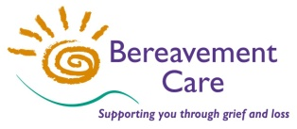
Bereavement Care

Online Zoom Webinar
When Covid Strikes
Responding to those bereaved during a pandemic

A webinar for bereavement visitors, counsellors, clergy, family support workers, healthcare professionals, community leaders, teachers and learning support assistants.

Wednesday 4th November 2020
9.30am – 1.00pm
Keynote Address by Julia Samuel MBE
-------------------------------------------------------------------------------------------------------------------------------------------------------
Outline Programme
9.30 am Online Registration, Welcome and Introductions
9.45 am Keynote Address: “Grief in the Time of Corona” Julia Samuel
10.30 am Q & A
11.00 am Comfort Break (with Information about Bereavement Care)
11.15 am Presentations on Bereavement and Grief during a Pandemic
“Delayed Grief” Ummi Merali
“The dual process model of Grief” Paul Parsons
“Supporting Children and Young People” Aaron Goldstein “Caring for Ourselves” Ruth Caleb
12.15 pm Q & A
12.45 pm Thanks, Reflection & Close
-------------------------------------------------------------------------------------------------------------------------------------------------------

How to book
Bookings are being taken through

To book visit the Bereavement Care Webinar Booking:
http://www.bereavementcareandsupport.co.uk/webinar/

Enter the amount you would like to donate in the box. Bereavement Care, a Registered Charity, is not charging for this Event. We suggest a minimum voluntary contribution of £15.

You will be emailed with details about how to connect to the Zoom Webinar closer to the time of the event. If you experience any difficulties with online booking, please contact the Bereavement Care office (details below).

Keynote Speaker
Julia Samuel MBE is a psychotherapist who has spent the last thirty years working with bereaved families. She has worked both in private practice and in the NHS at St Mary’s Hospital Paddington where she pioneered the role of maternity and paediatric psychotherapist. In 1994 she worked to launch and establish Child Bereavement UK as its Founder Patron, where she played a central role until September 2019. She is the author of two books: Grief Works and This Too Shall Pass.

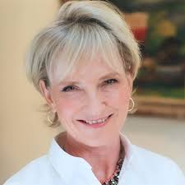

Presenters

Dr Ruth Caleb MBE is a Wellbeing Consultant and an Academic Adviser and tutor on the Metanoia Institute / Middlesex University Doctorate in Psychotherapy Programme. She was Head of Counselling at Brunel University London for over seventeen years and has over 30 years’ experience as a counsellor and psychotherapist. Ruth has a particular interest in working with life’s transitions, loss, counselling research and the development of resilience to bear life’s difficulties.

Rabbi Aaron Goldstein is Senior Rabbi of Northwood and Pinner Liberal Synagogue. He is chair of the Rabbinic Conference of Liberal Judaism and is currently a Trustee of Liberal Judaism and Leo Baeck College. He is passionate about counting people in, not out, and creating positive experiences through a sense of belonging and care.

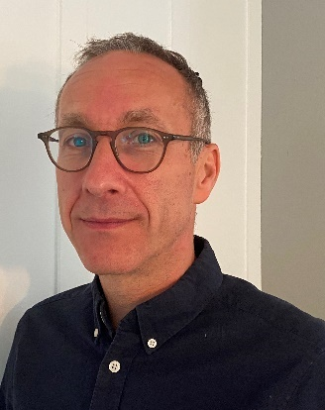

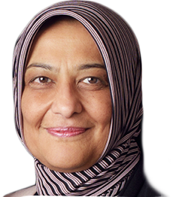
Ummi Merali is an internationally renowned scholar and teacher, who has an extensive background in Islamic education. She is one of the four founding members of Hujjat Saturday Workshop. As CEO and founder of Q Fatima, Ummi has worked tirelessly to produce excellent Islamic resources, which are simple, relevant and easy to understand. Ummi coordinates various interfaith activities as part of the Executive Committee of Harrow Interfaith.

Paul Parsons is the Adult Bereavement Service Co-ordinator at St Christopher’s Hospice and co-ordinates the London Borough of Bromley Bereavement Service. He has a Diploma in Supervision as well as completing a Diploma in Trauma and PTSD. He has been supporting many clients directly and indirectly affected by the Covid 19 pandemic. He has also developed and manages a Covid 19 response counselling service for a large Hospital Trust in partnership with the Hospice. Paul is actively involved in facilitating group work and is an accomplished trainer and supervisor in private practice.

