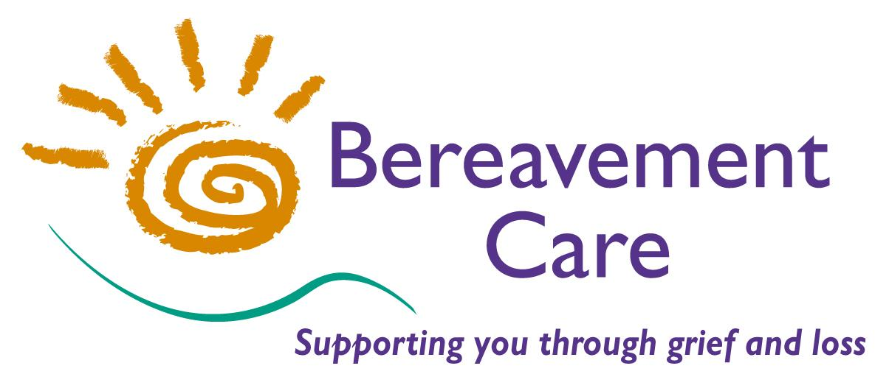

SAFEGUARDING CHILDREN
POLICY STATEMENT

Adopted: September 2014

APPROVED BY

The Chair of Trustees:

Signature: ______________________

Additional Trustee:

Signature: _____________________

REVISION HISTORY

ISSUE DATE REASON FOR CHANGE

Issue 1 09.2014 Created
Issue 2 10.2015 Reviewed
Issue 3 02.2017 Reviewed
Issue 4 02.2018 Revised
Issue 5 02.2019 Revised
Issue 6 02.2020 Revised
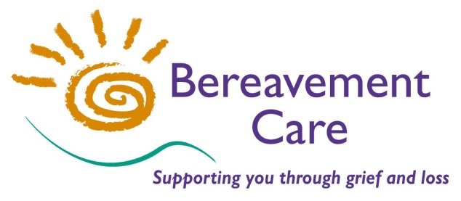
Bereavement Care
The Lodge, 64 Pinner Road
Harrow, Middlesex HA1 4HZ
Telephone: 020 8427 5720

Safeguarding Children Policy Statement
Safeguarding children is the responsibility of everyone

Statement of commitment
We are aware that many children and young people are victims of different kinds of abuse. We are also aware that many families experience hardship and various difficulties and they need support in order to provide adequate care for their children.
At Bereavement Care we aim to create an environment that is safe and we are committed to doing everything in our power to protect children, promote their welfare and support their families.

Purpose of this policy
The purpose of this policy is to:
- Effectively safeguard children and promote their rights and welfare
- Provide all staff and volunteers with clear rules to follow
- Make all staff and volunteers aware of what is expected of them in terms of their approach, behaviour and actions
- Give evidence to Bereavement Care users, parents and carers, the local community, partner organisations, the Local Authority and funding and commissioning bodies that Bereavement Care is committed to safeguarding.

Scope of this policy
This policy applies to all Bereavement Care staff and volunteers, including trustees and anyone working on behalf of Bereavement Care.

Definitions
Safeguarding and promoting the welfare of children is the process of:
- Protecting children from maltreatment.
- Preventing impairment of children’s health or development.
- Ensuring that children are growing up in circumstances consistent with the provision of safe and effective care.
- Taking action to enable all children to have the best life chances.

Child Protection is the process of protecting individual children identified as either suffering, or at risk of suffering significant harm as a result of abuse or neglect.

Legislative framework
At Bereavement Care we recognise our legal responsibility to safeguard children and promote their welfare. We will therefore act within the framework set by the Children Act 1989 and The Children Act 2004. We will also follow the Working Together to Safeguard Children 2013 guidance.
For our safeguarding procedures we adopt the Harrow Safeguarding Children Board (HSCB) Guidance 2017. (previously the Green Book) .
From 1 January 2019 there is a legal requirement to report a Serious Incident to the Charity Commission. This is in addition to any requirement to notify the police, local authority, statutory agency or other relevant authority. (see Appendix)

Underlying principles
At Bereavement Care we will endeavour to safeguard children by:

- Following the (HSCB) guidance in our day-to-day work
- Ensuring that safeguarding training for all children’s visitors is repeated every 2/3 years
- Ensuring that the Safeguarding Children Policy Statement is seen and understood by ALL visitors
- Keeping a record of Safeguarding training, as well as the most recent DBS check (dated) on the Bereavement Care office database.
- Listening to children and young people and respecting and valuing them at all times
- Challenging discrimination and promoting the right to equal protection regardless of race, ethnicity, culture, religion, faith, gender, sexual orientation, disability, social or immigration status or any other element of diversity
- Providing effective management to staff and volunteers through support, supervision and training.
- Recruiting staff and volunteers safely, ensuring that all necessary checks are made and safe recruitment good practice guidelines are followed
- Responding to both child protection and non-child protection concerns immediately
- In cases of doubt, questions or need for guidance, always seeking advice by calling the Harrow Golden Number (020 8901 2690), or, in cases involving staff/volunteers, the Local Authority Designated Officer (LADO) via the Golden Number
- Working in partnership with children, their parents and carers, members of the local community and local statutory and voluntary organisations
- Adhering to the Code of Best Practice when visiting Children & Young People at all times

Details of the Nominated Safeguarding Person and their Deputy

The Nominated Safeguarding Person for Bereavement Care is Edward Lewis
Role title: Chair of Trustees
The Deputy Nominated Safeguarding Person for Bereavement Care is Helena Reid
Role title: Trustee

Appendix
What is a safeguarding “Serious Incident”? A safeguarding Serious Incident is an adverse event, whether actual or alleged, which results in or risks significant harm to the charity’s beneficiaries, employees, office holders, volunteers or to others who come into contact with the charity through its work. This includes where there are allegations or incidents of abuse of or risks to beneficiaries or others connected with the charity’s activities. What is considered to be “significant” is a matter for the trustees to determine

Review arrangements
Bereavement Care will review this policy annually. In cases of relevant legal or local procedures changes, we will review this policy accordingly.

