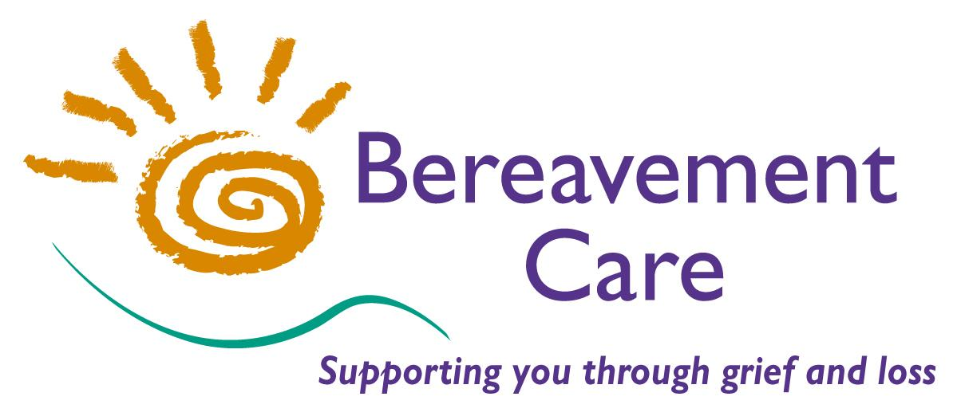

SAFEGUARDING ADULTS AT RISK
POLICY STATEMENT
including procedure for dealing with referrals from people who may have mental health problems

Adopted: February 2017

APPROVED BY

The Chair of Trustees:

Signature: ______________________

Additional Trustee:

Signature: _____________________

REVISION HISTORY

ISSUE DATE REASON FOR CHANGE

Issue 1 02.2017 Created
Issue 2 02.2018 Reviewed
Issue 3 02.2019 Revised
Issue 4 02.2020 Revised

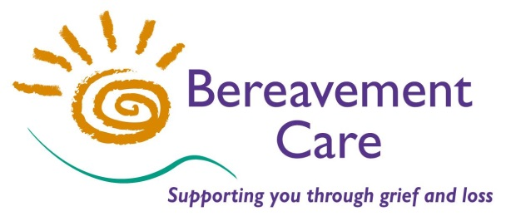
Bereavement Care
The Lodge, 64 Pinner Road
Harrow, Middlesex HA1 4HZ
Telephone: 020 8427 5720

Safeguarding Adults at Risk - Policy Statement
Protecting adults at risk is the responsibility of everyone

Statement of commitment
Bereavement Care recognises its responsibility to protect and safeguard the welfare of adults at risk (previously referred to as ‘vulnerable adults’). We are aware that many people are victims of different kinds of abuse.

Purpose of this policy
The purpose of this policy is to:
- Provide all staff and volunteers with clear principles to follow
- Make all staff and volunteers aware of what is expected of them in terms of their approach, behaviour and actions
- Give evidence to Bereavement Care users, the local community, partner organisations, the Local Authority, and funding and commissioning bodies that Bereavement Care is committed to safeguarding.
- Confirm the approach of Bereavement Care towards referrals from people with a mental illness (Please see *Appendix)

By following this policy, we will:
- Effectively safeguard adults at risk and promote their rights and welfare
- Help identify the physical, sexual, emotional or psychological, financial and discriminatory abuse and neglect of adults at risk by reporting any such abuse that is discovered or suspected.

Scope of this policy
This policy applies to all Bereavement Care staff and volunteers, including trustees and anyone working on behalf of Bereavement Care.

Definitions
Adults at risk are those aged 18 or over who are in need of care and support regardless of whether they are receiving them, and because of those needs are unable to protect themselves against abuse or neglect. An adult at risk is a person who may have:
- A learning or physical disability; and/or
- A physical or mental illness, chronic or otherwise, which may include addiction to alcohol or drugs; and/or
- A reduction in physical or mental capacity
and, as a result of this/these condition(s) may have:
- A dependency upon others in the performance of, or a requirement for assistance in the performance of, basic physical functions; and/or
- Severe impairment in the ability to communicate with others; and/or
- Impairment in the person’s ability to protect him or herself from assault, abuse or neglect
Safeguarding is defined as ‘protecting an adult’s right to live in safety, free from abuse and neglect.’
Underlying principles
At Bereavement Care we will endeavour to safeguard adults at risk by:

- Responding to safeguarding concerns immediately. From 1 January 2019 there is a legal requirement to report a Serious Incident to the Charity Commission. This is in addition to any requirement to notify the police, local authority, statutory agency or other relevant authority. (Please see **Appendix)
- Ensuring that any volunteer who visits an adult at risk has a current DBS check
- Listening to people and respecting and valuing them at all times
- Challenging discrimination and promoting the right to equal protection regardless of race, ethnicity, culture, religion, faith, gender, sexual orientation, disability, social or immigration status or any other element of diversity
- Providing effective management to staff and volunteers through support, supervision and training.
- Recruiting staff and volunteers safely, ensuring that all necessary checks are made and safe recruitment good practice guidelines are followed
- Responding to safeguarding concerns immediately
In cases of doubt, questions or need for guidance, always seek advice by calling the Local Authority Safeguarding Adults Board (SAB)
Harrow Safeguarding Adults Team:
Telephone: 020 8420 9453
Out of hours number Emergency Duty Team:
Telephone: 020 8424 0999

Hillingdon Safeguarding Adults Service:
Telephone: 01895 556 633
Out of hours number:
Telephone: 01895 250 111

For details of Safeguarding Adults Teams in other areas, contact the appropriate local authority via phone or website.

The Nominated Safeguarding Person for Bereavement Care is Edward Lewis

The Nominated Deputy Safeguarding Person for Bereavement Care is Helena Reid

Appendix.

*For people who may have mental health problems

Every effort will be made by the office to establish through the caller that the referral is suitable for Bereavement Care. If in doubt the office will contact the assessors &/or the honorary supervisor before continuing the referral procedure.
Normally referrals will not be accepted for:
- People who have a serious or acute mental illness and are receiving support from Mental Health Professionals
- People who are receiving professional counselling

** What is a safeguarding “Serious Incident”? A safeguarding Serious Incident is an adverse event, whether actual or alleged, which results in or risks significant harm to the charity’s beneficiaries, employees, office holders, volunteers or to others who come into contact with the charity through its work. This includes where there are allegations or incidents of abuse of or risks to beneficiaries or others connected with the charity’s activities. What is considered to be “significant” is a matter for the trustees to determine.

Review arrangements
Bereavement Care will review this policy annually. In cases of relevant legal or local procedural changes, we will review this policy accordingly.

