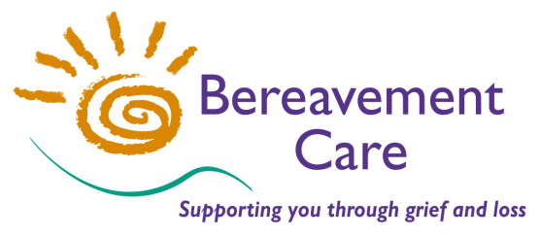
Bereavement Care
The Lodge, 64 Pinner Road
Harrow, Middlesex HA1 4HZ
Telephone: 020 8427 5720
Email: admin@bereavementcareandsupport.co.uk
www.bereavementcareandsupport.co.uk

APPLICATION FOR INDIVIDUAL MEMBERSHIP 2019

NAME:

ADDRESS:

POSTCODE: TELEPHONE:

EMAIL:

INDIVIDUAL MEMBERSHIP DECLARATION AND SUBSCRIPTION

I (PRINT NAME)
declare that I am concerned to further the objects of Bereavement Care.

I enclose* my Membership donation for 1st Jan - 31st Dec 2019 of £______

£5.00 MINIMUM DONATION PLEASE, but we are most grateful for any ADDITIONAL Voluntary Donations

*Please if you have paid by BACS Transfer.

Please make payment by Bank Transfer to: Bereavement Care
Sort Code: 40-23-13 Account Number: 42281287 Reference: Individual membership
or by cheque payable to: Bereavement Care

I am a UK taxpayer intending tax to be reclaimed on the enclosed.

Please if your donation is made under the Gift Aid scheme.
Please treat this as a Gift Aid donation. I confirm I have paid or will pay an amount of Income Tax and/or Capital Gains Tax for each tax year (6 April to 5 April) that is at least equal to the amount of tax that all the charities and Community Amateur Sports Clubs that I donate to will reclaim on my gifts for that tax year. I understand the charity will reclaim 25p of tax on every £1 that I give.

PLEASE I agree to my contact details (above) being held by Bereavement Care and I give my consent for this data
TO OPT IN to be used by representatives of Bereavement Care to communicate with me regarding news and
information, including courses and events. I understand that my details will be held in accordance with the

General Data Protection Regulations and will not be shared with third parties outside of Bereavement Care.

SIGNED: DATE:

If you are a member of a Bereavement Visiting Group or Corporate Member, please state its name:

