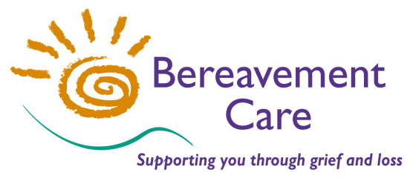
Bereavement Care
The Lodge, 64 Pinner Road
Harrow, Middlesex HA1 4HZ
Telephone: 020 8427 5720
Email: admin@bereavementcareandsupport.co.uk
www.bereavementcareandsupport.co.uk

APPLICATION FOR CORPORATE MEMBERSHIP 2017

NAME OF MEMBER ORGANISATION:

NAME & CONTACT DETAILS OF CORRESPONDENT FOR MEMBER ORGANISATION:

NAME:
ADDRESS:

POSTCODE: TELEPHONE:
E-MAIL ADDRESS:

NAME & CONTACT DETAILS OF NOMINATED REPRESENTATIVE: (if different from above)

NAME:
ADDRESS:

POSTCODE: TELEPHONE:
E-MAIL ADDRESS:

I declare on behalf of (organisation’s name) that we are concerned to further the objects of Bereavement Care. We agree to follow Bereavement Care’s Codes of Best Practice for Visiting Adults, Young People & Children.

SIGNED: DATE: POSITION:

CORPORATE MEMBERSHIP FEE FOR 1st January – 31st December 2017
The Corporate Membership Fee of £200 p.a.* (January – December) entitles a member to:
- One FREE place on the Initial Bereavement Training Course (payment to be made in advance and refunded upon the candidate attending and completing the course);
- Reduced fees for additional training, workshops and the Annual Conference;
- The right to vote at any Annual General Meeting (and any Extra-ordinary Meetings);
- An electronic copy** of the Annual Report & Accounts;
- Correspondence sent by e-mail** including newsletters, events and information related to Bereavement Care and its operation.
[* Smaller organisations may be offered a reduced fee at the discretion of the Trustees]
[** Paper copies of documents may be requested by contacting our office]

Please make payment by Bank Transfer to: Bereavement Care
Sort Code: 40-23-13 Account Number: 42281287 Reference: Corporate membership
or by cheque payable to: Bereavement Care

Please if your organisation has a Bereavement Visiting Group.

