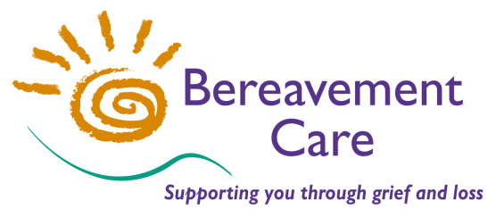
Bereavement Care
The Lodge, 64 Pinner Road
Harrow, Middlesex HA1 4HZ
Telephone: 020 8427 5720
Email: admin@bereavementcareandsupport.co.uk
www.bereavementcareandsupport.co.uk

APPLICATION FOR INDIVIDUAL MEMBERSHIP 2017

NAME: ……………………………………………………………………………………………..

ADDRESS: …………………………………………………………………………………………

…………………………………………………………………………………………………………

…………………………………………………………………………………………………………

POSTCODE: ………………………….. TELEPHONE: ………………………………………

EMAIL: ………………………………………………………………………………………………

INDIVIDUAL MEMBERSHIP DECLARATION AND SUBSCRIPTION

I ………………………………………………………………………………………………………… (PRINT NAME) declare that I am concerned to further the objects of Bereavement Care.

I enclose* my Membership donation for 1st Jan - 31st Dec 2017 of £______

(MINIMUM £5.00 We are grateful for any additional Voluntary Contributions)

*Please if you have paid by BACS Transfer.

Please make payment by Bank Transfer to: Bereavement Care
Sort Code: 40-23-13 Account Number: 42281287 Reference: Individual membership
or by cheque payable to: Bereavement Care

I am a UK taxpayer intending tax to be reclaimed on the enclosed.

Please if your donation is made under the Gift Aid scheme.
Please treat this as a Gift Aid donation. I confirm I have paid or will pay an amount of Income Tax and/or Capital Gains Tax for each tax year (6 April to 5 April) that is at least equal to the amount of tax that all the charities and Community Amateur Sports Clubs that I donate to will reclaim on my gifts for that tax year. I understand the charity will reclaim 25p of tax on every £1 that I give.

SIGNED: ………………………………………………………DATE: ………………………….

If you are a member of a Bereavement Visiting Group or Corporate Member, please state its name:

………………………………………………………………………………………………………………………………………

