Living with dementia was a key theme of this year’s bereavement care conference, held at Mosaic Reform.
With rapidly increasing numbers – currently there are 850,000 people in the UK living with dementia – this devastating loss, for the sufferer and the carer, will become a growing issue for bereavement groups.
Padraic Garrett, who leads Jewish Care’s innovative and unique Arts, Disability and Dementia Team was one of the panellists at the conference, which was opened by Harrow Mayor, Cllr Rekha Shah at Bessborough Road, Harrow on November 2.
He said: “This is a word so many people fear. A lot of people over 50 say it’s one of the things they fear most. It’s very hard to say, yes, I have dementia. It’s why so many people don’t seek a diagnosis.” He stressed how important it was to get help from the professionals to access medical and psychological support as soon as possible.
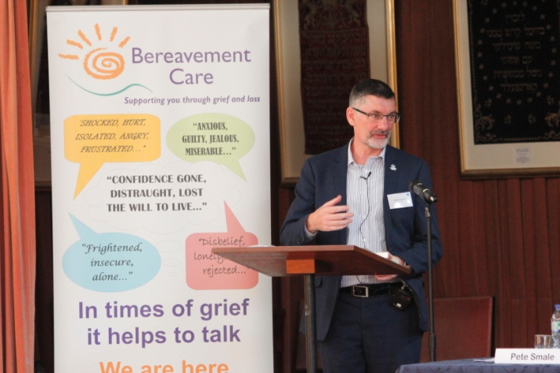
He added:”It’s hard to face up to something degenerative, but also very hard for the carer. There is a lot of stigma about mental health and about dementia. People do still walk away from you. There is life with dementia. The majority are living in the community. People can live for a long time with a good quality of life.”
The mayor also spoke of the anguish of losing someone you know “even if they are still with you” and said people with dementia had been neglected by society in the past.
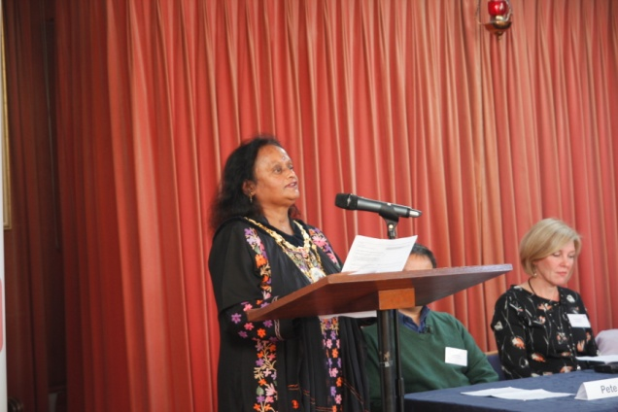

Wendy Weidner, business development manager for Dementia UK, said: When someone gets a diagnosis there is a huge sense of loss. The thing to remember is that the person is still there. She also spoke about the amazing work Admiral nurses do in giving holistic support to the entire family.
Elizabeth Carruthers, a psychotherapist based at the Lynda Jackson Macmillan Centre at Mount Vernon hospital, spoke about living with cancer and how it was no longer “the death sentence it used to be.” She said 1,000 people a day were diagnosed with some form of cancer and stressed that psychological support was just as important as physical support.
She said: We would not leave someone in physical pain. Why would we leave someone in emotional pain?” It’s a lot about loss: confronting your mortality, isolation. Even with a good prognosis there are many things you grieve for: your health, a job, hope for the future, relationships.”
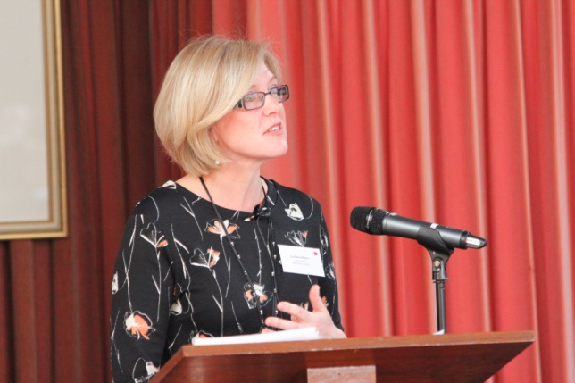
Pete Smale, from Child Bereavement UK, spoke about the support they give families when they lose children and children who lose someone they love. He said: “A parent of a child under 18 dies every 22 minutes in the UK.”
“We explore feelings and emotions. Young people are encouraged to talk about what helps them and what doesn’t work.”
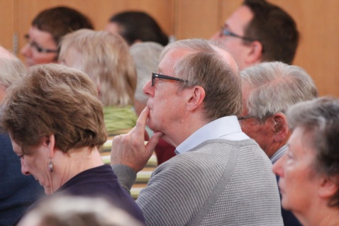
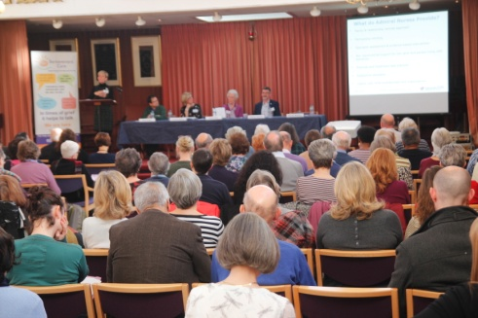
Judy Silverton, Mosaic Reform member and chairwoman of the conference planning group, welcomed delegates from multi-faith groups, individuals and organisations to the 35th annual bereavement care conference. She thanked the sponsors as well as the volunteers who supplied a superb lunch.
A series of workshops: Anticipatory loss from a cancer perspective, Living with Loss – When a family member has dementia, Preparing children for the death of a family member and supporting dementia patients were run by the panellists.
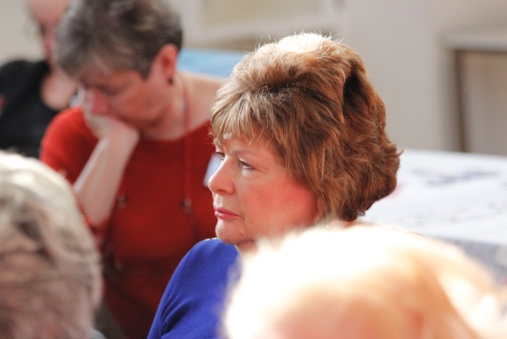
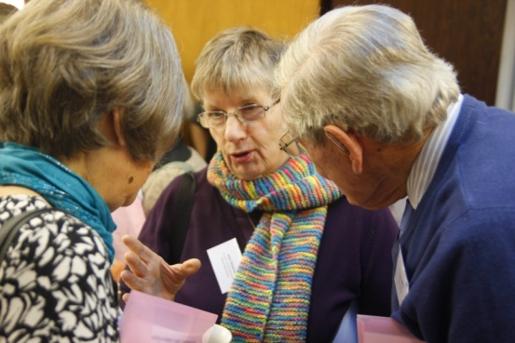

Richard Conradi, group leader for the combined Bereavement support group for Northwood and Pinner Liberal and Northwood United synagogues, spoke briefly about the importance of advanced personal information to help families cope when they lose someone.
He spoke movingly about his personal struggles when dealing with the affairs of family members because of lack of basic information. A relevant form can be downloaded from the Bereavement Care website.
Article by Jane Harrison
Photos by David Pollak

